**CECS 456 – Assignment 3**

**Due date: 9/26/2023 11:59PM**

**Objective:**

In this assignment we are going to investigate simple Cross Entropy method

**Assignments:**

1. (10 pts) Consider the Cross Entropy cost for logistic regression equation:

$g\left(w\right)= -\frac{1}{P}\sum_{p=1}^{P}{y_{p}\log\left(σ\left({\dot{x}}_{p}^{T}w\right)\right)+\left(1-y_{p}\right)\log\left(1-σ\left({\dot{x}}_{p}^{T}w\right)\right)}$ (1)

The gradient of this function can be computed as:

$∇g\left(w\right)=-\frac{1}{P}\sum_{p=1}^{P}{\left(y_{p}-σ\left({\dot{x}}_{p}^{T}w\right)\right)}{\dot{x}}_{p}$ (2)

Derive equation (2) manually.

1. (30 pts) Write a python program that minimizes the Cross Entropy logistic regression.

The dataset that is used for the image 1 (also in the lecture note) is given to you.

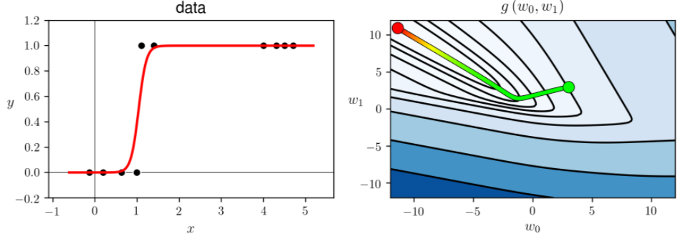

(Image 1)

You don’t need to reproduce the contour plot on the right panel (although it is cool, how about extra credit!). However, you can verify that your implementation is working properly by reproducing the final fir shown in left panel.

Show your results for the following settings:

Setting1: $w_{0}=3, w_{1}=3, α=1, k=25$

Setting1: $w_{0}=3, w_{1}=3, α=1, k=2000$

**Submission:**

1. To answer question1, you need to show me derivative steps. For formulas you can use Latex in Jupyter. If you are not familiar with Latex you can write your derivative results on a paper and insert the image of your manual writing in the Jupyter.
2. On the top of your Jupyter notebook, add your name and student ID.
3. Any answers and discussion must be included in the Jupyter document (No separate file).
4. Your code must be reasonably clean (e.g no extra code, left overs, unnecessary outputs, intermediate debugging code etc.)
5. Before submission run your code from beginning to the end, so all results are saved in your Jupyter document and can be seen before I run it myself.
6. Submit your Jupyter notebook on Canvas.